**INTERVIEW QUESTIONS**

1. **Memory Layout in C program**

Text segment  
Initialized data segment  
Uninitialized data segment  
Stack  
Heap

[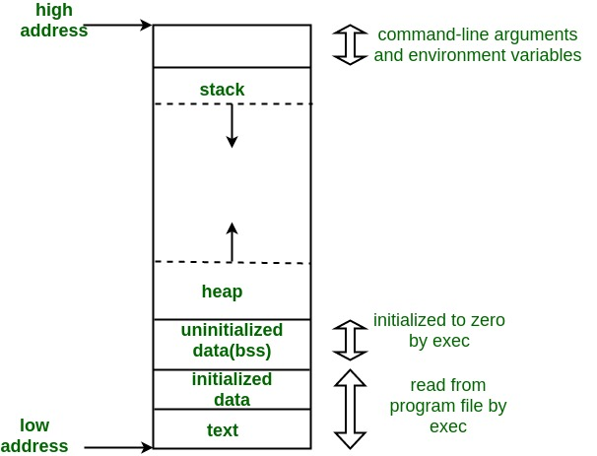](https://cdncontribute.geeksforgeeks.org/wp-content/uploads/memoryLayoutC.jpg)

**Text Segment:**  
A text segment, also known as a code segment or simply as text, is one of the sections of a program in an object file or in memory, which contains executable instructions.

As a memory region, a text segment may be placed below the heap or stack in order to prevent heaps and stack overflows from overwriting it. text segment is often read-only, to prevent a program from accidentally modifying its instructions.

**Initialized Data Segment:**  
Initialized data segment, usually called simply the Data Segment. A data segment is a portion of virtual address space of a program, which contains the global variables and static variables that are initialized by the programmer.

Note that, data segment is not read-only, since the values of the variables can be altered at run time.

This segment can be further classified into initialized read-only area and initialized read-write area.

For instance the global string defined by char s[] = “hello world” in C and a C statement like int debug=1 outside the main (i.e. global) would be stored in initialized read-write area. And a global C statement like const char* string = “hello world” makes the string literal “hello world” to be stored in initialized read-only area and the character pointer variable string in initialized read-write area.

**Uninitialized Data Segment:**  
Uninitialized data segment, often called the “bss” segment, named after an ancient assembler operator that stood for “block started by symbol.” Data in this segment is initialized by the kernel to arithmetic 0 before the program starts executing

uninitialized data starts at the end of the data segment and contains all global variables and static variables that are initialized to zero or do not have explicit initialization in source code.

For instance a variable declared static int i; would be contained in the BSS segment.  
For instance a global variable declared int j; would be contained in the BSS segment.

**Stack:**  
The stack area traditionally adjoined the heap area and grew the opposite direction; when the stack pointer met the heap pointer, free memory was exhausted.

The stack area contains the program stack, a LIFO structure, typically located in the higher parts of memory.

A “stack pointer” register tracks the top of the stack; it is adjusted each time a value is “pushed” onto the stack. The set of values pushed for one function call is termed a “stack frame”; A stack frame consists at minimum of a return address.

Stack, where automatic variables are stored, along with information that is saved each time a function is called. Each time a function is called, the address of where to return to and certain information about the caller’s environment, such as some of the machine registers, are saved on the stack. The newly called function then allocates room on the stack for its automatic and temporary variables. This is how recursive functions in C can work. Each time a recursive function calls itself, a new stack frame is used, so one set of variables doesn’t interfere with the variables from another instance of the function.

**Heap:**  
Heap is the segment where dynamic memory allocation usually takes place.

The heap area begins at the end of the BSS segment and grows to larger addresses from there.The Heap area is managed by malloc, realloc, and free, which may use the brk and sbrk system calls to adjust its size (note that the use of brk/sbrk and a single “heap area” is not required to fulfill the contract of malloc/realloc/free; they may also be implemented using mmap to reserve potentially non-contiguous regions of virtual memory into the process’ virtual address space). The Heap area is shared by all shared libraries and dynamically loaded modules in a process.

1. **Where are static and global variables stored?**

They are both stored in the data segment (if initialised then initialized data segment, if not bss)

1. **What is an interrupt? Explain its proves.**

An interrupt is a signal to the processor emitted by hardware or software indicating an event that needs immediate attention. Whenever an interrupt occurs, the controller completes the execution of the current instruction and starts the execution of an Interrupt Service Routine (ISR) or Interrupt Handler. ISR tells the processor or controller what to do when the interrupt occurs. The interrupts can be either hardware interrupts or software interrupts.

Hardware Interrupt

A hardware interrupt is an electronic alerting signal sent to the processor from an external device, like a disk controller or an external peripheral. For example, when we press a key on the keyboard or move the mouse, they trigger hardware interrupts which cause the processor to read the keystroke or mouse position.

Software Interrupt

A software interrupt is caused either by an exceptional condition or a special instruction in the instruction set which causes an interrupt when it is executed by the processor. For example, if the processor's arithmetic logic unit runs a command to divide a number by zero, to cause a divide-by-zero exception, thus causing the computer to abandon the calculation or display an error message. Software interrupt instructions work similar to subroutine calls.

|  |  |
| --- | --- |
| **Interrupt** | **Polling** |
| An interrupt is like a **shopkeeper**. If one needs a service or product, he goes to him and apprises him of his needs. In case of interrupts, when the flags or signals are received, they notify the controller that they need to be serviced. | The polling method is like a **salesperson**. The salesman goes from door to door while requesting to buy a product or service. Similarly, the controller keeps monitoring the flags or signals one by one for all devices and provides service to whichever component that needs its service. |

## Steps to Execute an Interrupt

When an interrupt gets active, the microcontroller goes through the following steps −

* The microcontroller closes the currently executing instruction and saves the address of the next instruction (PC) on the stack.
* It also saves the current status of all the interrupts internally (i.e., not on the stack).
* It jumps to the memory location of the interrupt vector table that holds the address of the interrupts service routine.
* The microcontroller gets the address of the ISR from the interrupt vector table and jumps to it. It starts to execute the interrupt service subroutine, which is RETI (return from interrupt).
* Upon executing the RETI instruction, the microcontroller returns to the location where it was interrupted. First, it gets the program counter (PC) address from the stack by popping the top bytes of the stack into the PC. Then, it start to execute from that address.